Project Design Phase-II
Technology Stack (Architecture & Stack)
Date | 01 October 2026
Team ID | SWTID-2026-4457
Project Name | Script-Controlled ACL – Restrict Record Access Based on Field Value
Maximum Marks | 4 Marks

Technical Architecture:
The Deliverable shall include the architectural diagram as below and the information as per the table1 & table 2
Example: Script-controlled ACL for restricting record access based on field value (ServiceNow)
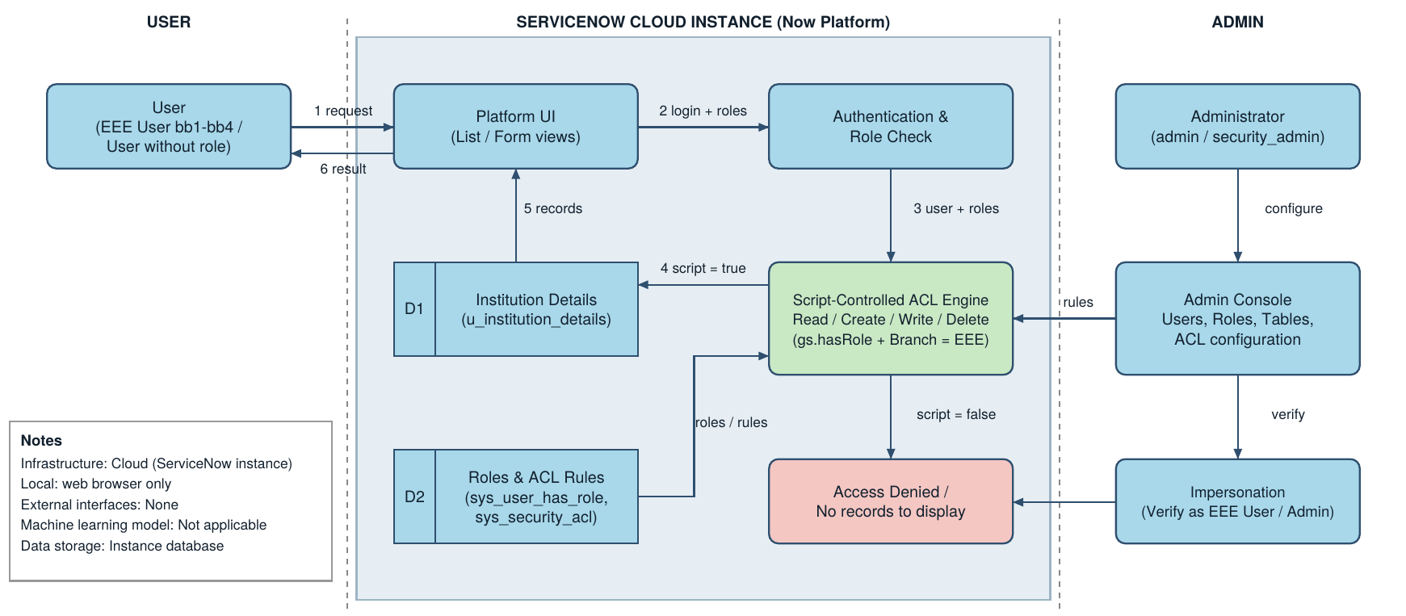
Table-1 : Components & Technologies:
S.No | Component | Description | Technology
1. | User Interface | Users (EEE User, Admin) interact with the Institution Details list and form through the ServiceNow web interface; the New button and edit options appear only for permitted roles. | ServiceNow Platform UI (browser: HTML, CSS, JavaScript)
2. | Application Logic-1 | Authentication and role check: user logs in and the roles assigned (bb1, bb2, bb3, bb4, admin) are read. | ServiceNow User Administration, Roles, gs.hasRole()
3. | Application Logic-2 | Script-controlled Read ACL (Advanced): data condition Branch is EEE; script returns true for admin or bb1, otherwise false. | ServiceNow ACL, JavaScript (ECMAScript 2021 mode)
4. | Application Logic-3 | Create, Write and Delete ACLs that require roles bb2, bb3 and bb4 respectively. | ServiceNow ACL (Allow If, Requires role)
5. | Database | Custom table u_institution_details with Student Roll Number, Student Name, Faculty Name, Branch (ECE, EEE, CSE), Email, Phone Number, Description. | ServiceNow platform database (custom table)
6. | Cloud Database | Records, users, roles and ACL rules are stored in the cloud-hosted ServiceNow instance. | ServiceNow cloud instance database
7. | File Storage | No separate file storage is required; all data is held in the instance. | ServiceNow instance storage
8. | External API-1 | Not used in this project. | N/A
9. | External API-2 | Not used in this project. | N/A
10. | Machine Learning Model | Not applicable to this project. | N/A
11. | Infrastructure (Server / Cloud) | Application deployment on cloud. Local Server Configuration: web browser only. Cloud Server Configuration: ServiceNow-hosted instance (Global application scope). | ServiceNow Cloud
Table-2: Application Characteristics:
S.No | Characteristics | Description | Technology
1. | Open-Source Frameworks | The platform is ServiceNow; ACL logic is written in standard JavaScript. No separate open-source framework is used. | JavaScript (ES12), ServiceNow Glide API
2. | Security Implementations | Record-level Read, Create, Write and Delete ACLs; role-based access control; data condition (Branch is EEE); default deny (return false); security_admin elevation required to edit ACLs. | ServiceNow ACLs, RBAC, gs.hasRole()
3. | Scalable Architecture | Cloud multi-tier platform; more roles, branches, users and records can be added by creating roles and ACLs or updating the script and data condition. | ServiceNow Now Platform
4. | Availability | The solution is available whenever the cloud-hosted ServiceNow instance is available; no extra servers are managed by the project team. | ServiceNow cloud infrastructure
5. | Performance | ACLs use simple role checks and a field condition evaluated on the server, so list views load quickly for the small Institution Details table. | Server-side ACL evaluation (ServiceNow)
References:
https://c4model.com/
https://docs.servicenow.com (Access Control Rules, Script-controlled ACLs)

